**Machine Learning Algorithm for the image classification**

**What have I learned about SVM?**

In this assignment, I learned about image classification using Support Vector Machine (SVM), which is a supervised learning algorithm. It is used to solve both classification and regression tasks. It is primarily used for classification tasks by classifying the elements of dataset into two groups.

SVM uses a hyperplane to help show the largest separation between different classes. Below, a picture is shown of a hyperplane in two dimensions where a line is used to separate between two classes. The other terminology that I learned is support vector, which represents the data points that lie closest to the hyperplane. The SVM algorithm uses these support vectors to maximize the margin. The last terminology is the margin, which shows the distance between the hyperplane and the nearest data points from each class by aiming to maximize the margin.

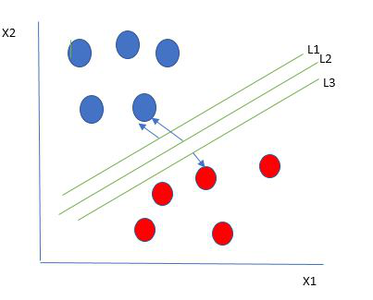

I learned that Support Vector Machines (SVMs) offer several advantages in image classification, particularly their effectiveness in high-dimensional spaces, robustness, and versatility with different kernel functions. Some common kernels include linear, polynomial, and radial basis function (RBF), making them suitable for handling complex data distributions. Linear kernels (we used SVC(kernel='linear')) are used for linearly separable data, while polynomial kernels handle more complex, non-linear data patterns using Gaussian function by mapping them into higher dimensions.

However, SVMs also present limitations, including computational complexity and memory intensity, especially with non-linear kernels and the need for extensive experimentation to choose the optimal kernel and parameters. I especially realized the scalability issues when dealing with very large datasets.

**My first image classification using machine learning algorithm**

To explore the basics of image classification using the CIFAR-10 dataset, I started following the given instructions. Firstly, I installed libraries together using pip install, numpy for numerical operations, matplotlib for plotting and visualizing images, tensorflow for loading the CIFAR-10 dataset and scikit-learn (sklearn) for machine learning models and evaluation metrics. After this, I loaded the data with a reduced data size. Then, I converted the image to gray scale, flatten the images and labels, and displayed the image with training and testing sizes. Below is an example of a sample image from the CIFAR-10 dataset. I noticed that the image is very grainy and hard to see.

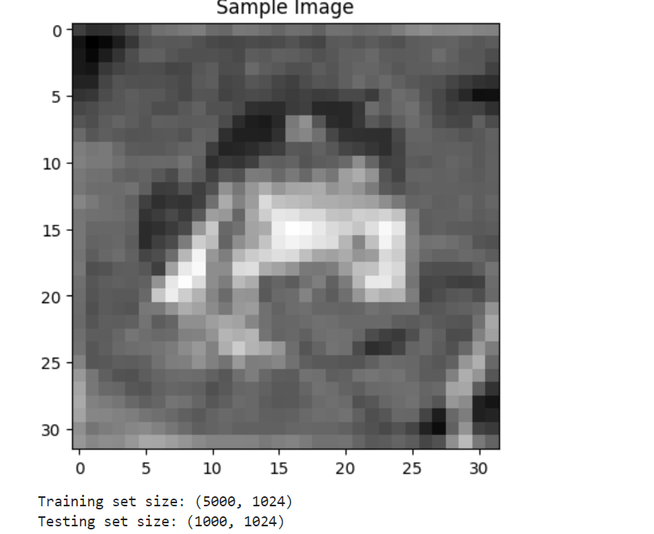

Then we ran the code to trains a Support Vector Machine (SVM) classifier with a linear kernel on a flattened grayscale version of the training data (`X_train_gray_flat`, `y_train`). It is used to predict labels for the test set (`X_test_gray_flat`) and evaluates the model's performance, printing the accuracy and a detailed classification report that includes precision, recall, and F1-score for each class. Below are the results from the model evaluation.

**Results from SVM classification on CIFAR-10 data**

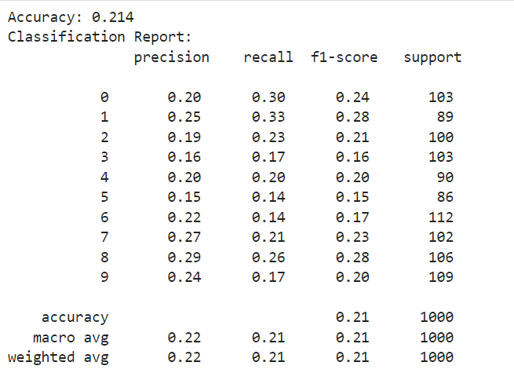

This data shows that the model performs poorly, achieving only 21.4% accuracy. The classification report indicates low precision, recall, and F1-scores across all classes, reflecting the model's inadequate performance in distinguishing between the different classes in the test set. This suggests that the linear kernel may not be suitable for this data, or that additional preprocessing and feature extraction might be necessary.

Reference

* **Support Vector Machine (SVM) Algorithm**

<https://www.geeksforgeeks.org/support-vector-machine-algorithm/>